# VISVESVARAYA TECHNOLOGICAL UNIVERSITY

**BELAGAVI – 590018, Karnataka**



**INTERNSHIP REPORT**

**ON**

# “TEMPLATE FOR COURSEZZ: SITE TO SELL COURSES”

*Submitted in partial fulfillment for the award of degree (18CSI85)*

***Bachelor of Engineering in Information Science and Engineering***

**Submitted by:**

**JAYANTH BN (1DB19CS061)**



Conducted at

## Varcons Technologies Pvt Ltd



**Department of Computer Science and Engineering**

**Don Bosco Institute of Technology**

**Kumbalgodu, Bengaluru-74**

**2022-2023**

# DON BOSCO INSTITUTE OF TECHNOLOGY

**Mysore Road, Kumbalgodu, Bengaluru-560074**

**(Affiliated to Visvesvaraya Technological University, Belagavi)**

**Department of Computer Science and Engineering**



**CERTIFICATE**

This is to certify that the Internship entitled **“Template for Coursezz- site to sell courses”** carried out by **JAYANTH BN (1DB19CS061),** a Bonafide student of **Don Bosco Institute of Technology**, in partial fulfillment for the award of the Degree of Bachelor of Engineering, in Computer Science and Engineering under Visvesvaraya Technological University, Belagavi during the year 2022-2023. It is certified that all corrections/suggestions indicated have been incorporated in the report.

The project report has been approved as it satisfies the academic requirements in respect of Internship prescribed for the course Internship / Professional Practice (18CSI85)

##### Signature of Guide Signature of HOD Signature of Principal

**External Viva:**

Name of the Examiner Signature with Date

1)

2)

# D E C L A R A T I O N

I, **JAYANTH BN,** final year student of Computer Science and Engineering, - 560 082, **Don Bosco Institute of Technology** declare that the Internship has been successfully completed, in **Varcons Technologies Pvt Ltd.** This report is submitted in partial fulfillment of the requirements for award of Bachelor Degree in Computer Science and Engineering, during the academic year 2022-2023.

Date: 06-03-2023

Place: Bangalore

Name and USN: JAYANTH BN (1DB19CS061)

# OFFER LETTER PROVIDED BY THE COMPANY



Internship offer letter 

Date: **6th February, 2023**

Name: **Jayanth BN**

USN: **1DB19CS061**

**Dear Student,**

We would like to congratulate you on being selected for the **Full Stack Web Development** Internship position with **Varcons Technologies Pvt Ltd**, effective Start Date **6th February, 2023**, All of us are excited about this opportunity provided to you!

This internship is viewed as being an educational opportunity for you, rather than a part-time job. As such, your internship will include training/orientation and focus primarily on learning and developing new skills and gaining a deeper understanding of concepts of **Full Stack Web Development** through hands-on application of the knowledge you learn while you train with the senior developers. You will be bound to follow the rules and regulations of the company during your internship duration.

Again, congratulations and we look forward to working with you! Sincerely,

Spoorthi H C

**Director**

Varcons Technologies Pvt Ltd

*213, 2st Floor, 18 M G Road, Ulsoor,*

*Bangalore-560001*

# A C K N O W L E D G E M E N T

This Internship is a result of accumulated guidance, direction and support of several important persons. We take this opportunity to express our gratitude to all who have helped us to complete the Internship.

We express our sincere thanks to our principal, for providing us adequate facilities to undertake this Internship.

We would like to thank our Head of Dept – branch code, for providing us an opportunity to carry out Internship and for his valuable guidance and support.

We would like to thank our (Lab assistant name) Software Services for guiding us during the period of internship.

We express our deep and profound gratitude to our guide, Guide name, Assistant/Associate Prof, for her keen interest and encouragement at every step in completing the Internship.

We would like to thank all the faculty members of our department for the support extended during the course of Internship.

We would like to thank the non-teaching members of our dept, for helping us during the Internship.

Last but not the least, we would like to thank our parents and friends without whose constant help, the completion of Internship would have not been possible.

**JAYANTH BN (1DB19CS061)**

# ABSTRACT

This project **“Coursezz- Site to sell courses”** is a system based on web application which is useful for everyone to learn new things. This system mainly deals to manage the online courses for users. This application has been designed and developed a comprehensive web-based system to better support everyone benefit and requirement.

It offers a wide range of high-quality online courses to help you achieve your personal and professional goals. Whether you're looking to learn a new skill, advance in your career, or simply explore a new subject, we have something for you.

Our courses are designed and taught by industry experts and professionals who are passionate about their fields. They bring real-world experience and practical knowledge to the virtual classroom, ensuring that you receive the most relevant and up-to-date information.

It offers courses in a variety of formats, including live webinars, pre-recorded lectures, interactive workshops, and self-paced modules. This allows you to learn at your own pace and on your own schedule, making our courses accessible and convenient for everyone.

Our user-friendly platform makes it easy to search for courses, enroll, and track your progress. You'll also have access to a supportive community of fellow learners, where you can share ideas, ask questions, and receive feedback.

At our course selling website, we're committed to providing you with the best possible learning experience. With our comprehensive course offerings, expert instructors, and flexible formats, we're confident that you'll find the perfect course to help you achieve your goals..

# Table of Contents:

|  |  |  |
| --- | --- | --- |
| **SL NO** | **DESCRIPTION** | **PAGE NO** |
| 1 | Company Profile | 8 |
| 2 | About the Company | 9 |
| [3](https://1.bp.blogspot.com/-dODuK8N5h1Q/Wlnyb3V9HFI/AAAAAAAACL4/WxQtCJ1pM5wccDABg4wIrTBUB0vlikXQQCLcBGAs/s1600/poly1.jpg) | Introduction | 13 |
| 4 | Requirement Analysis | 15 |
| 5 | Design [Analysis](https://4.bp.blogspot.com/-IOOxgPaXMVc/Wlj3LWvcnjI/AAAAAAAACKE/UeTFYvAxDmUDel5UBjdifeWaApB3-dXVgCLcBGAs/s1600/img1.jpg) | 16 |
| 6 | [Implementation](https://4.bp.blogspot.com/-IOOxgPaXMVc/Wlj3LWvcnjI/AAAAAAAACKE/UeTFYvAxDmUDel5UBjdifeWaApB3-dXVgCLcBGAs/s1600/img1.jpg) | 17 |
| 7 | Snapshots | 35 |
| 8 | Conclusion | 38 |
| 9 | References | 39 |

1. **COMPANY PROFILE**

## A Brief History of Varcons Technologies

Varcons Technologies, was incorporated with a goal” To provide high quality and optimal Technological Solutions to business requirements of our clients”. Every business is different and has a unique business model and so are the technological requirements. They understand this and hence the solutions provided to these requirements are different as well. They focus on clients’ requirements and provide them with tailor made technological solutions. They also understand that Reach of their Product to its targeted market or the automation of the existing process into an e-client and simple process are the key features that our clients desire from the Technological Solution they are looking for and these are the features that we focus on while designing the solutions for their clients.

Sarvamoola Software Services. is a Technology Organization providing solutions for all web design and development, MYSQL, PYTHON Programming, HTML, CSS, ASP.NET and LINQ. Meeting the ever-increasing automation requirements, Sarvamoola Software Services. specialize in ERP, Connectivity, SEO Services, Conference Management, effective web promotion and tailor-made software products, designing solutions best suiting clients’ requirements.

Varcons Technologies, strive to be the front runner in creativity and innovation in software development through their well-researched expertise and establish it as an out of the box software development company in Bangalore, India. As a software development company, they translate this software development expertise into value for their customers through their professional solutions.

They understand that the best desired output can be achieved only by understanding the client's demand better. Varcons Technologies work with their clients and help them to define their exact solution requirement. Sometimes even they wonder if they have completely redefined their solution or new application requirement during the brainstorming session, and here they position themselves as an IT solutions consulting group composed of high caliber consultants.

Varcons Technologies is a leading provider of cutting-edge technologies and services, offering scalable solutions for businesses of all sizes. Founded by a group of friends who started by scribbling their ideas on a piece of paper, today we offer smart, innovative services to dozens of clients. We develop SaaS products, provide Corporate Seminars, Industrial trainings and much more.

# ABOUT THE COMPANY



Varcons Technologies is a Technology Organization providing solutions for all web design and development, MYSQL, PYTHON Programming, HTML, CSS, ASP.NET and LINQ. Meeting the ever-increasing automation requirements, Varcons Technologies specialize in ERP, Connectivity, SEO Services, Conference Management, effective web promotion and tailor-made software products, designing solutions best suiting clients’ requirements. The organization where they have a right mix of professionals as a stakeholder to help us serve our clients with best of our capability and with at par industry standards. They have young, enthusiastic, passionate and creative Professionals to develop technological innovations in the field of Mobile technologies, Web applications as well as Business and Enterprise solution. Motto of our organization is to “Collaborate with our clients to provide them with best Technological solution hence creating Good Present and Better Future for our client which will bring a cascading a positive effect in their business shape as well”. Providing a Complete suite of technical solutions is not just our tag line, it is Our Vision for Our Clients and for Us, we strive hard to achieve it.

### Products of Varcons Technologies.

* + 1. **Android Apps**

It is the process by which new applications are created for devices running the Android operating system. Applications are usually developed in Java (and/or Kotlin; or other such option) programming language using the Android software development kit (SDK), but other development environments are also available, some such as Kotlin support the exact same Android APIs (and bytecode), while others such as Go have restricted API access.

The Android software development kit includes a comprehensive set of development tools. These include a debugger, libraries, a handset emulator based on QEMU, documentation, sample code, and tutorials. Currently supported development platforms include computers running Linux (any modern desktop Linux distribution), Mac OS X 10.5.8 or later, and Windows 7 or later. As of March 2015, the SDK is not available on Android itself, but software development is possible by using specialized Android application

* + 1. **Web Application**

It is a client–server computer program in which the client (including the user interface and client-side logic) runs in a web browser. Common web applications include web mail, online

retail sales, online auctions, wikis, instant messaging services and many other functions. web applications use web documents written in a standard format such as HTML and JavaScript, which are supported by a variety of web browsers. Web applications can be considered as a specific variant of client–server software where the client software is downloaded to the client machine when visiting the relevant web page, using standard procedures such as HTTP. The Client web software updates may happen each time the web page is visited. During the session, the web browser interprets and displays the pages, and acts as the universal client for any web application. The use of web application frameworks can often reduce the number of errors in a program, both by making the code simpler, and by allowing one team to concentrate on the framework while another focuses on a specified use case. In applications which are exposed to constant hacking attempts on the Internet, security- related problems can be caused by errors in the program.

Frameworks can also promote the use of best practices such as GET after POST. There are some who view a web application as a two-tier architecture. This can be a “smart” client that performs all the work and queries a “dumb” server, or a “dumb” client that relies on a “smart” server. The client would handle the presentation tier, the server would have the database (storage tier), and the business logic (application tier) would be on one of them or on both. While this increases the scalability of the applications and separates the display and the database, it still doesn’t allow for true specialization of layers, so most applications will outgrow this model. An emerging strategy for application software companies is to provide web access to software previously distributed as local applications. Depending on the type of application, it may require the development of an entirely different browser-based interface, or merely adapting an existing application to use different presentation technology. These programs allow the user to pay a monthly or yearly fee for use of a software application without having to install it on a local hard drive. A company which follows this strategy is known as an application service provider (ASP), and ASPs are currently receiving much attention in the software industry.

Security breaches on these kinds of applications are a major concern because it can involve both enterprise information and private customer data. Protecting these assets is an important part of any web application and there are some key operational areas that must be included in the development process. This includes processes for authentication, authorization, asset handling, input, and logging and auditing. Building security into the applications from the beginning can be more effective and less disruptive in the long run.

* + 1. **Web design**

It is encompassing many different skills and disciplines in the production and maintenance of websites. The different areas of web design include web graphic design; interface design; authoring, including standardized code and proprietary software; user experience design; and search engine optimization. The term web design is normally used to describe the design process relating to the front-end (client side) design of a website including writing mark up. Web design partially overlaps web engineering in the broader scope of web development. Web designers are expected to have an awareness of usability and if their role involves creating markup then they are also expected to be up to date with web accessibility guidelines. Web design partially overlaps web engineering in the broader scope of web development.

### Departments and services offered

Varcons Technologies plays an essential role as an institute, the level of education, development of student’s skills is based on their trainers. If you do not have a good mentor then you may lag in many things from others and that is why we at Varcons Technologies gives you the facility of skilled employees so that you do not feel unsecured about the academics. Personality development and academic status are some of those things which lie on mentor’s hands. If you are trained well then you can do well in your future and knowing its importance of Varcons Technologies always tries to give you the best.

They have a great team of skilled mentors who are always ready to direct their trainees in the best possible way they can and to ensure the skills of mentors we held many skills development programs as well so that each and every mentor can develop their own skills with the demands of the companies so that they can prepare a complete packaged trainee.

### Services provided by Varcons Technologies.

VCA provides a host of services to its customers/users/clients, enabling business success driven by technology Harnessing the power of technology, we create a measurable difference for our clients across various industries & multiple geographies.

##### Website as Software

We develop websites that behave and interact similar to sophisticated software.

##### Search Engine Optimisation

We help you manage your SEO campaign more efficiently and effectively. We help you gain market share by leveraging our expertise. our holistic approach to identify anything that may be hurting your traffic or rankings and show you just how to outrank the competition.

##### Branding and Design

We offer professional Graphic design, Brochure design & Logo design. We are experts in crafting visual content to convey the right message to the customers. We also design custom wraps for your products (also known as package designing)

##### Analytics and Research

We analyse the way your users/customers interact with you/your business by gathering, studying and understanding the consumer voice and their perception of the product/service

##### Comprehensive Customer Support

With a comprehensive range of services, we guarantee your technology needs are not just met, but exceeded. We shall work with your customers/users closely to understand the way your users/customers use/make use of products/services

# INTRODUCTION

## Introduction to Full Stack Web Development

Full stack web development is the work involved in developing a [website](https://en.wikipedia.org/wiki/Web_site) for the [Internet](https://en.wikipedia.org/wiki/Internet) ([World](https://en.wikipedia.org/wiki/World_Wide_Web) [Wide Web](https://en.wikipedia.org/wiki/World_Wide_Web)) or an [intranet](https://en.wikipedia.org/wiki/Intranet) (a private network).Web development can range from developing a simple single [static page](https://en.wikipedia.org/wiki/Static_Web_page) of [plain text](https://en.wikipedia.org/wiki/Plain_text) to complex [web applications](https://en.wikipedia.org/wiki/Web_application), [electronic businesses](https://en.wikipedia.org/wiki/Electronic_business), and [social network services.](https://en.wikipedia.org/wiki/Social_network_service) A more comprehensive list of tasks to which Web development commonly refers, may include [Web engineering,](https://en.wikipedia.org/wiki/Web_engineering) [Web design,](https://en.wikipedia.org/wiki/Web_design) [Web content development](https://en.wikipedia.org/wiki/Web_content_development), client liaison, [client-side](https://en.wikipedia.org/wiki/Client-side_scripting)/[server-side scripting,](https://en.wikipedia.org/wiki/Server-side_scripting) [Web server](https://en.wikipedia.org/wiki/Web_server) and [network security](https://en.wikipedia.org/wiki/Network_security) configuration, and [e-](https://en.wikipedia.org/wiki/E-commerce) [commerce](https://en.wikipedia.org/wiki/E-commerce) development. Among Web professionals, "Web development" usually refers to the main non-design aspects of building Web sites: writing [markup](https://en.wikipedia.org/wiki/Markup_language) and coding. Web development may use [content management systems](https://en.wikipedia.org/wiki/Content_management_system) (CMS) to make content changes easier and available with basic technical skills. For larger organizations and businesses, Web development teams can consist of hundreds of people ([Web developers](https://en.wikipedia.org/wiki/Web_developer)) and follow standard methods like [Agile](https://en.wikipedia.org/wiki/Agile_software_development) [methodologies](https://en.wikipedia.org/wiki/Agile_software_development) while developing Web sites. Smaller organizations may only require a single permanent or contracting developer, or secondary assignment to related job positions such as a [graphic designer](https://en.wikipedia.org/wiki/Graphic_designer) or [information systems](https://en.wikipedia.org/wiki/Information_systems) technician. Web development may be a collaborative effort between departments rather than the domain of a designated department. There are three kinds of Web developer specialization: [front-end developer,](https://en.wikipedia.org/wiki/Front-end_Web_development) back-end developer, and full-stack developer. Front-end developers are responsible for behavior and visuals that run in the user browser, while back-end developers deal with the servers. Since the commercialization of the Web with [Tim Berners-Lee](https://en.wikipedia.org/wiki/Tim_Berners-Lee) developing the World Wide Web at CERN, the industry has boomed and has become one of the most used technologies ever.

#### They can be accessed from anywhere.

* Because web applications are built with web technologies and they run in a web browser Internet Explorer, Google Chrome, Mozilla Firefox – this allows them to be accessed from every web enabled tool. As long as you have an internet connection you can use them.
* It allows for remote working, it allows for rapid publishing of content, it allows for real time collaboration between teams. If you have web access, you have the ability to access your business tools.

#### They are cost effective.

* Web applications are cheaper to produce and maintain than traditional applications. No matter how many platforms your business uses (Mac, Linux, Windows) web application build can be used across them all.

#### They benefit from more rapid update cycles.

* A huge benefit of web applications is that when an update is released, all of your users using that version. This doesn’t happen with installed applications, especially in large organizations with IT policies that restrict administrator access.

#### They are secure.

* Web developers have had to become experts in security – the web is a platform designed to share everything with everyone! As such, the types and levels of security included in web applications are often far greater than those seen in traditional applications.
* They also benefit from the ability to launch updates in real-time – the application on the servers is the application people are using. The applications on people’s laptops however is the version last installed. And when those laptops get left on a train it’s not a concern, as nothing is stored locally.

#### They enable more computing with fewer Information.

* Web applications push all of the hard work to the servers, and act as intermediaries between the user interface and the calculations happening behind the scenes. This means you can accomplish terrifyingly complex work on a tablet, or your phone.
* We’ve built web applications that allow people to understand the complex relationships between 250,000 pieces of art on their phones, and applications that run the business systems of one of the largest solar energy providers in the world. Often these products are not financially viable to build using traditional application processes.
  1. **Problem Statement**

Develop an application which facilitates creation of web pages having a need to install any HTML editor-based software and also which can be used by any novice user (no HTML knowledge needed) that is developing web pages on the online. This module is designed to reduce the process involved in managing the activity of customers and business where the business can sell their services and the customers can buy those.

### Introduction to B2C Ecommerce Website Development with Admin Panel

B2C E-commerce website content providers to focus on creating effective assessment questions and focusing on providing a platform for easy access between Buyer and Consumer.

Here we present techniques that are pertinent to the elements of assessment process: answers submission, Information zed grading, and feedback after submission. As the modern organizations are automated and Information’s are working as per the instructions, it becomes essential for the coordination of human beings, commodity and Information’s in a modern organization.

# REQUIREMENT ANALYSIS

### Hardware Requirement Specification

* + - Microsoft’s Visual Studio IDE
    - Live Server Extension
    - Notepad++ Editor
    - Processor: Intel core i7 processer
    - Memory: 15.6 GB
    - Hard Disk: 40 GB

### Software Requirement Specification

#### Functional Requirements

* + Content to be entered by the user
  + Operations performed by each screen
  + Content approval work-flow process
  + Availability and downtime of the application
  + This includes security of the content and encryption

#### Non-Functional Requirements

##### Availability

The online registration system shall permit backing up of the registration database while other registration actives are going on.

##### Accessibility

The system shall be accessible by people with specific vision needs to the extent that a user shall be able to display whole user interface in a larger font without truncating displayed text or other values.

##### Security

The access permissions for system data may only be change by the systems data administrator passwords shall never be viewable at the point of entry or any other time.

# DESIGN & ANALYSIS

# C:\Users\p nageswara rao\Pictures\Screenshots\Screenshot (142).png

1. **IMPLEMENTATION**

### DESCRIPTION (FRONT END)

* + 1. **INTRODUCTION TO HTML (Hyper Text Markup Language):**

**HTML** stands for Hyper Text Markup Language. It is used to design web pages using a markup language. HTML is the combination of Hypertext and Markup language. Hypertext defines the link between web pages. A markup language is used to define the text document within the tag which defines the structure of web pages. This language is used to annotate (make notes for the computer) text so that a machine can understand it and manipulate text accordingly. Most markup languages (e.g., HTML) are human-readable. The language uses tags to define what manipulation has to be done on the text.

HTML is a markup language used by the browser to manipulate text, images, and other content, in order to display it in the required format. HTML was created by Tim Berners-Lee in 1991.

The first-ever version of HTML was HTML 1.0, but the first standard version was HTML 2.0, published in 1995.

### INTRODUCTION TO CSS (Cascade style sheets):

Cascading Style Sheets (CSS) is a style sheet language used for describing the presentation of a document written in a mark-up language. Although most often used to set the visual style of web pages and user interfaces written in HTML and XHTML, the language can be applied to any XML document, including plain XML, SVG and XUL, and is applicable to rendering in speech, or on other media. Along with HTML and JavaScript, CSS is a cornerstone technology used by most websites to create visually engaging webpages, user interfaces for web applications, and user interfaces for many mobile applications.

CSS is designed primarily to enable the separation of presentation and content, including aspects such as the layout, colors, and fonts. This separation can improve content accessibility, provide more flexibility and control in the specification of presentation characteristics, enable multiple HTML pages to share formatting by specifying the relevant CSS in a separate .CSS file, and reduce complexity and repetition in the structural content.

### INTRODUCTION TO JS (JavaScript):

JavaScript is an open-source programming language designed for creating web-centric applications. It is lightweight and interpreted which makes it much faster than other languages and is integrated with [HTML](https://www.simplilearn.com/html-interview-questions-and-answers-article) making it easier to implement in web applications.

* + - * JavaScript is the most popular programming language in the world and that makes it a default choice for web development. There are many frameworks available which you can use to create web applications once you have learned JavaScript.
      * JavaScript offers lots of flexibility. You can create stunning and fast web applications with tons of customizations to provide users with the most relevant graphical user interface.
      * JavaScript is now also used in mobile app development, desktop app development, and game development. This opens many possibilities for you as a JavaScript developer.
      * Due to the high demand in the industry, there are tons of job growth opportunities and high pay for those who know JavaScript.
      * The incredible thing about JavaScript is that you can find tons of frameworks and libraries already developed, which can be used directly in web development. That reduces the development time and enhances the graphical user interface.

### INTRODUCTION TO PHP (Hypertext Preprocessor):

* + - * Hypertext Preprocessor (or simply PHP) is a server-side scripting language designed for web development but also used as a general-purpose programming language.
      * It was originally created by Rasmus Lerdorf in 1994; the PHP reference implementation is now produced by The PHP Group. PHP originally stood for Personal Home Page, but it now stands for the recursive acronym PHP: Hypertext Preprocessor.
      * PHP code may be embedded into HTML code, or it can be used in combination with various web template systems, web content management systems, and web frameworks.
      * PHP code is usually processed by a PHP interpreter implemented as a module in the web server or as a Common Gateway Interface (CGI) executable.
      * The web server combines the results of the interpreted and executed PHP code, which may be any type of data, including images, with the generated web page.
      * PHP code may also be executed with a command-line interface (CLI) and can be used to implement standalone graphical applications.
  1. **SOURCE CODE**

### Index.html

<!DOCTYPE html>

<html lang="en">

<head>

  <meta charset="utf-8">

  <meta content="width=device-width, initial-scale=1.0" name="viewport">

  <title>Coursezz-Site to sell courses-Index</title>

  <meta content="" name="description">

  <meta content="" name="keywords">

  <!-- Favicons -->

  <link href="assets/img/Logo1.png" rel="icon">

  <link href="assets/img/Logo1.png" rel="apple-touch-icon">

  <!-- Google Fonts -->

  <link

    href="https://fonts.googleapis.com/css?family=Open+Sans:300,300i,400,400i,600,600i,700,700i|Raleway:300,300i,400,400i,500,500i,600,600i,700,700i|Poppins:300,300i,400,400i,500,500i,600,600i,700,700i"

    rel="stylesheet">

  <!-- Vendor CSS Files -->

  <link href="assets/vendor/animate.css/animate.min.css" rel="stylesheet">

  <link href="assets/vendor/aos/aos.css" rel="stylesheet">

  <link href="assets/vendor/bootstrap/css/bootstrap.min.css" rel="stylesheet">

  <link href="assets/vendor/bootstrap-icons/bootstrap-icons.css" rel="stylesheet">

  <link href="assets/vendor/boxicons/css/boxicons.min.css" rel="stylesheet">

  <link href="assets/vendor/remixicon/remixicon.css" rel="stylesheet">

  <link href="assets/vendor/swiper/swiper-bundle.min.css" rel="stylesheet">

  <!-- Template Main CSS File -->

  <link href="assets/css/style.css" rel="stylesheet">

  <!-- =======================================================

  * Template Name: Coursezz - v4.10.0

  * Template URL: https://bootstrapmade.com/Coursezz-free-education-bootstrap-theme/

  * Author: BootstrapMade.com

  * License: https://bootstrapmade.com/license/

  ======================================================== -->

</head>

<body>

  <!-- ======= Header ======= -->

  <header id="header" class="fixed-top">

    <div class="container d-flex align-items-center">

      <h1 class="logo me-auto"><a href="index.html">Coursezz</a></h1>

      <!-- Uncomment below if you prefer to use an image logo -->

      <!-- <a href="index.html" class="logo me-auto"><img src="assets/img/logo.png" alt="" class="img-fluid"></a>-->

      <nav id="navbar" class="navbar order-last order-lg-0">

        <ul>

          <li><a class="active" href="index.html">Home</a></li>

          <li><a href="about.html">About</a></li>

          <li><a href="courses.html">Courses</a></li>

          <li><a href="trainers.html">Trainers</a></li>

          <li><a href="events.html">Events</a></li>

          <li><a href="pricing.html">Pricing</a></li>

          <li><a href="contact.html">Contact</a></li>

        </ul>

        <i class="bi bi-list mobile-nav-toggle"></i>

        <div class="mx-3">

          <button type="button" class="btn btn-success" data-bs-toggle="modal"

            data-bs-target="#loginModal">Login</button>

          <button type="button" class="btn btn-danger" data-bs-toggle="modal"

            data-bs-target="#signupModal">Sign-Up</button>

        </div>

      </nav><!-- .navbar -->

      <a href="courses.html" class="get-started-btn">Get Started</a>

    </div>

    </div>

  </header><!-- End Header -->

  <!-- LoginModal -->

  <div class="modal fade" id="loginModal" tabindex="-1" aria-labelledby="loginModalLabel" aria-hidden="true">

    <div class="modal-dialog">

      <div class="modal-content">

        <div class="modal-header">

          <h2>Login</h2>

          <button type="button" class="btn-close" data-bs-dismiss="modal" aria-label="Close"></button>

        </div>

        <div class="modal-body">

          <form>

            <div class="mb-3">

              <label for="exampleInputEmail1" class="form-label">Email address</label>

              <input type="email" class="form-control" id="exampleInputEmail1" aria-describedby="emailHelp">

              <div id="emailHelp" class="form-text">We'll never share your email with anyone else.</div>

            </div>

            <div class="mb-3">

              <label for="exampleInputPassword1" class="form-label">Password</label>

          </ul>

        </div>

      </div>

    </section><!-- End About Section -->

    <!-- ======= Counts Section ======= -->

    <section id="counts" class="counts section-bg">

      <div class="container">

        <div class="row counters">

          <div class="col-lg-3 col-6 text-center">

            <span data-purecounter-start="0" data-purecounter-end="1232" data-purecounter-duration="1"

              class="purecounter"></span>

            <p>Students</p>

          </div>

          <div class="col-lg-3 col-6 text-center">

            <span data-purecounter-start="0" data-purecounter-end="64" data-purecounter-duration="1"

              class="purecounter"></span>

            <p>Courses</p>

          </div>

          <div class="col-lg-3 col-6 text-center">

            <span data-purecounter-start="0" data-purecounter-end="42" data-purecounter-duration="1"

              class="purecounter"></span>

            <p>Events</p>

          </div>

          <div class="col-lg-3 col-6 text-center">

            <span data-purecounter-start="0" data-purecounter-end="15" data-purecounter-duration="1"

              class="purecounter"></span>

            <p>Trainers</p>

          </div>

        </div>

      </div>

    </section><!-- End Counts Section -->

    <!-- ======= Why Us Section ======= -->

    <section id="why-us" class="why-us">

      <div class="container" data-aos="fade-up">

                      journey. No matter what you are looking to learn, or gain confidence in, Coursera has something

                      for you.”</div>

                  </div>

                </div>

                <div class="col-xl-4 d-flex align-items-stretch">

                  <div class="icon-box mt-4 mt-xl-0">

                    <img src="CarlosC-Coursera-Learner.png" width="150px">

                    <h5>Carlos C</h5>

                    <div>USA</div>

                    <div>“I was able to prove to potential employers that I have a solid understanding of computers and

                      hardware—and started to receive real, viable job offers.”</div>

                  </div>

                </div>

              </div>

            </div><!-- End .content-->

          </div>

        </div>

      </div>

    </section><!-- End Why Us Section -->

    <!-- ======= Features Section ======= -->

    <section id="features" class="features">

      <div class="container" data-aos="fade-up">

        <div class="row" data-aos="zoom-in" data-aos-delay="100">

          <div class="col-lg-3 col-md-4">

            <div class="icon-box">

              <i class="ri-store-line" style="color: #ffbb2c;"></i>

              <h3><a href="">Artficial Intelligence</a></h3>

            </div>

          </div>

          <div class="col-lg-3 col-md-4 mt-4 mt-md-0">

            <div class="icon-box">

              <i class="ri-bar-chart-box-line" style="color: #5578ff;"></i>

              <h3><a href="">Machine Learning</a></h3>

            </div>

          </div>

          <div class="col-lg-3 col-md-4 mt-4 mt-md-0">

            <div class="icon-box">

              <i class="ri-calendar-todo-line" style="color: #e80368;"></i>

              <h3><a href="">Web Development</a></h3>

            </div>

          </div>

          <div class="col-lg-3 col-md-4 mt-4 mt-lg-0">

            <div class="icon-box">

              <i class="ri-paint-brush-line" style="color: #e361ff;"></i>

              <h3><a href="">Full-Stack Development</a></h3>

        </div>

                 <p class="price">$250</p>

                </div>

                <h3><a href="course-details.html">Search Engine Optimization</a></h3>

                <p>Et architecto provident deleniti facere repellat nobis iste. Id facere quia quae dolores dolorem

                  tempore.</p>

                <div class="trainer d-flex justify-content-between align-items-center">

                  <div class="trainer-profile d-flex align-items-center">

                    <img src="assets/img/trainers/trainer-2.jpg" class="img-fluid" alt="">

                    <span>Lana</span>

                  </div>

                  <div class="trainer-rank d-flex align-items-center">

                    <i class="bx bx-user"></i>&nbsp;35

                    &nbsp;&nbsp;

                    <i class="bx bx-heart"></i>&nbsp;42

                  </div>

                </div>

              </div>

            </div>

          </div> <!-- End Course Item-->

          <div class="col-lg-4 col-md-6 d-flex align-items-stretch mt-4 mt-lg-0">

            <div class="course-item">

              <img src="assets/img/course-3.jpg" class="img-fluid" alt="...">

              <div class="course-content">

                <div class="d-flex justify-content-between align-items-center mb-3">

                  <h4>Content</h4>

                  <p class="price">$180</p>

                </div>

                <h3><a href="course-details.html">Copywriting</a></h3>

                <p>Et architecto provident deleniti facere repellat nobis iste. Id facere quia quae dolores dolorem

                  tempore.</p>

                <div class="trainer d-flex justify-content-between align-items-center">

                  <div class="trainer-profile d-flex align-items-center">

                    <img src="assets/img/trainers/trainer-3.jpg" class="img-fluid" alt="">

                    <span>Brandon</span>

                  </div>

                  <div class="trainer-rank d-flex align-items-center">

                    <i class="bx bx-user"></i>&nbsp;20

                    &nbsp;&nbsp;

                    <i class="bx bx-heart"></i>&nbsp;85

                  </div>

                </div>

              </div>

            </div>

          </div> <!-- End Course Item-->

        </div>

      </div>

    </section><!-- End Popular Courses Section -->

    <!-- ======= Trainers Section ======= -->

    <section id="trainers" class="trainers">

      <div class="container" data-aos="fade-up">

        <div class="row" data-aos="zoom-in" data-aos-delay="100">

          <div class="col-lg-4 col-md-6 d-flex align-items-stretch">

            <div class="member">

              <img src="assets/img/trainers/trainer-1.jpg" class="img-fluid" alt="">

              <div class="member-content">

                <h4>Walter White</h4>

                <span>Web Development</span>

                <p>

                  I feel great that I got the opportunity to work with one of the best universities on my own schedule.

                  It will elevate my life, and my family's life overall, to help me grow my career into the latest

                  technology trends.

                </p>

                <div class="social">

                  <a href=""><i class="bi bi-twitter"></i></a>

                  <a href=""><i class="bi bi-facebook"></i></a>

                  <a href=""><i class="bi bi-instagram"></i></a>

                  <a href=""><i class="bi bi-linkedin"></i></a>

                </div>

              </div>

            </div>

          </div>

          <div class="col-lg-4 col-md-6 d-flex align-items-stretch">

            <div class="member">

              <img src="assets/img/trainers/trainer-2.jpg" class="img-fluid" alt="">

              <div class="member-content">

                <h4>Sarah Jhinson</h4>

                <span>Marketing</span>

                <p>

                  In our program, we combine the expertise of teaching faculty who bring in solid ideas and frameworks

                  with the hands-on expertise of seasoned entrepreneurs who function as mentors.

                </p>

                <div class="social">

                  <a href=""><i class="bi bi-twitter"></i></a>

                  <a href=""><i class="bi bi-facebook"></i></a>

                  <a href=""><i class="bi bi-instagram"></i></a>

                  <a href=""><i class="bi bi-linkedin"></i></a>

                </div>

              </div>

            </div>

          </div>

          <div class="col-lg-4 col-md-6 d-flex align-items-stretch">

            <div class="member">

              <img src="assets/img/trainers/trainer-3.jpg" class="img-fluid" alt="">

              <div class="member-content">

                <h4>William Anderson</h4>

                <span>Content</span>

                <p>

                  Each week of every course, you will join a live global classroom. You will be involved in

                  give-and-take discussions with faculty, not just listen to us. You will work on real-world accounting

                  problems.

                </p>

                <div class="social">

                  <a href=""><i class="bi bi-twitter"></i></a>

                  <a href=""><i class="bi bi-facebook"></i></a>

                  <a href=""><i class="bi bi-instagram"></i></a>

                  <a href=""><i class="bi bi-linkedin"></i></a>

                </div>

              </div>

            </div>

          </div>

        </div>

      </div>

    </section><!-- End Trainers Section -->

  </main><!-- End #main -->

  <!-- ======= Footer ======= -->

  <footer id="footer">

    <div class="footer-top">

      <div class="container">

        <div class="row">

          <div class="col-lg-3 col-md-6 footer-contact">

            <h3>Coursezz</h3>

            <p>

              A108 Adam Street <br>

    <div class="container d-md-flex py-4">

      <div class="me-md-auto text-center text-md-start">

        <div class="copyright">

          &copy; Copyright <strong><span>Coursezz</span></strong>. All Rights Reserved

        </div>

        <div class="credits">

          <!-- All the links in the footer should remain intact. -->

          <!-- You can delete the links only if you purchased the pro version. -->

          <!-- Licensing information: https://bootstrapmade.com/license/ -->

          <!-- Purchase the pro version with working PHP/AJAX contact form: https://bootstrapmade.com/Coursezz-free-education-bootstrap-theme/ -->

          Designed by <a href="https://bootstrapmade.com/">SoftwareChasers</a>

        </div>

      </div>

      <div class="social-links text-center text-md-right pt-3 pt-md-0">

        <a href="#" class="twitter"><i class="bx bxl-twitter"></i></a>

        <a href="#" class="facebook"><i class="bx bxl-facebook"></i></a>

        <a href="#" class="instagram"><i class="bx bxl-instagram"></i></a>

        <a href="#" class="google-plus"><i class="bx bxl-skype"></i></a>

        <a href="#" class="linkedin"><i class="bx bxl-linkedin"></i></a>

      </div>

    </div>

  </footer><!-- End Footer -->

  <div id="preloader"></div>

  <a href="#" class="back-to-top d-flex align-items-center justify-content-center"><i

      class="bi bi-arrow-up-short"></i></a>

  <!-- Vendor JS Files -->

  <script src="assets/vendor/purecounter/purecounter_vanilla.js"></script>

  <script src="assets/vendor/aos/aos.js"></script>

  <script src="assets/vendor/bootstrap/js/bootstrap.bundle.min.js"></script>

  <script src="assets/vendor/swiper/swiper-bundle.min.js"></script>

  <script src="assets/vendor/php-email-form/validate.js"></script>

  <!-- Template Main JS File -->

  <script src="assets/js/main.js"></script>

</body>

</html>

### stylepay.css

*{

    margin: 0;

    padding: 0;

    box-sizing: border-box;

  }

  body{

    background-color: #f5f5f5;

    font-family: Arial, Helvetica, sans-serif;

  }

  .wrapper{

    background-color: #fff;

    width: 500px;

    padding: 25px;

    margin: 25px auto 0;

    box-shadow: 0px 0px 20px rgba(0,0,0,0.5);

  }

  .wrapper h2{

    background-color: #fcfcfc;

    color: #2b84ea;

    font-size: 24px;

    padding: 10px;

    margin-bottom: 20px;

    text-align: center;

    border: 1px dotted #333;

  }

  h4{

    padding-bottom: 5px;

    color: #2b84ea;

  }

  .input-group{

    margin-bottom: 8px;

    width: 100%;

    position: relative;

    display: flex;

    flex-direction: row;

    padding: 5px 0;

  }

  .input-box{

    width: 100%;

    margin-right: 12px;

    position: relative;

  }

  .input-box:last-child{

    margin-right: 0;

  }

  .name{

    padding: 14px 10px 14px 50px;

    width: 100%;

    background-color: #fcfcfc;

    border: 1px solid #00000033;

    outline: none;

    letter-spacing: 1px;

    transition: 0.3s;

    border-radius: 3px;

    color: #333;

  }

  .name:focus, .dob:focus{

    -webkit-box-shadow:0 0 2px 1px #2b84ea80;

    -moz-box-shadow:0 0 2px 1px #2b84ea80;

    box-shadow: 0 0 2px 1px #2b84ea80;

    border: 1px solid #2b84ea;

  }

  .input-box .icon{

    width: 48px;

    display: flex;

    justify-content: center;

    align-items: center;

    position: absolute;

    top: 0px;

    left: 0px;

    bottom: 0px;

    color: #333;

    background-color: #f1f1f1;

    border-radius: 2px 0 0 2px;

    transition: 0.3s;

    font-size: 20px;

    pointer-events: none;

    border: 1px solid #00000033;

    border-right: none;

  }

  .name:focus + .icon{

    background-color: #2b84ea;

    color: #fff;

    border-right: 1px solid #2b84ea;

    border: none;

    transition: 1s;

  }

  .dob{

    width: 30%;

    padding: 14px;

    text-align: center;

    background-color: #fcfcfc;

    transition: 0.3s;

    outline: none;

    border: 1px solid #c0bfbf;

    border-radius: 3px;

  }

  .radio{

    display: none;

  }

  .input-box label{

    width: 50%;

    padding: 13px;

    background-color: #fcfcfc;

    display: inline-block;

    float: left;

    text-align: center;

    border: 1px solid #c0bfbf;

  }

  .input-box label:first-of-type{

    border-top-left-radius: 3px;

    border-bottom-left-radius: 3px;

    border-right: none;

  }

  .input-box label:last-of-type{

    border-top-right-radius: 3px;

    border-bottom-right-radius: 3px;

  }

  .radio:checked + label{

    background-color: #2b84ea;

    color: #fff;

    transition: 0.5s;

  }

  .input-box select{

    display: inline-block;

    width: 50%;

    padding: 12px;

    background-color: #fcfcfc;

    text-align: center;

    font-size: 16px;

    outline: none;

    border: 1px solid #c0bfbf;

    cursor: pointer;

    transition: all 0.2s ease;

  }

  .input-box select:focus{

    background-color: #2b84ea;

    color: #fff;

    text-align: center;

  }

  button{

    width: 100%;

    background: transparent;

    border: none;

    background: #2b84ea;

    color: #fff;

    padding: 15px;

    border-radius: 4px;

    font-size: 16px;

    transition: all 0.35s ease;

  }

  button:hover{

    cursor: pointer;

    background: #5eb105;

  }

  #start{

    width="100px";

}

### main.js

/**

* Template Name: Mentor - v4.10.0

* Template URL: https://bootstrapmade.com/mentor-free-education-bootstrap-theme/

* Author: BootstrapMade.com

* License: https://bootstrapmade.com/license/

*/

(function() {

  "use strict";

  /**

   * Easy selector helper function

   */

  const select = (el, all = false) => {

    el = el.trim()

    if (all) {

      return [...document.querySelectorAll(el)]

    } else {

      return document.querySelector(el)

    }

  }

  /**

   * Easy event listener function

   */

  const on = (type, el, listener, all = false) => {

    let selectEl = select(el, all)

    if (selectEl) {

      if (all) {

        selectEl.forEach(e => e.addEventListener(type, listener))

      } else {

        selectEl.addEventListener(type, listener)

      }

    }

  }

  /**

   * Easy on scroll event listener

   */

  const onscroll = (el, listener) => {

    el.addEventListener('scroll', listener)

  }

  /**

   * Back to top button

   */

  let backtotop = select('.back-to-top')

  if (backtotop) {

    const toggleBacktotop = () => {

      if (window.scrollY > 100) {

        backtotop.classList.add('active')

      } else {

        backtotop.classList.remove('active')

      }

    }

    window.addEventListener('load', toggleBacktotop)

    onscroll(document, toggleBacktotop)

  }

  /**

   * Mobile nav toggle

   */

  on('click', '.mobile-nav-toggle', function(e) {

    select('#navbar').classList.toggle('navbar-mobile')

    this.classList.toggle('bi-list')

    this.classList.toggle('bi-x')

  })

  /**

   * Mobile nav dropdowns activate

   */

  on('click', '.navbar .dropdown > a', function(e) {

    if (select('#navbar').classList.contains('navbar-mobile')) {

      e.preventDefault()

      this.nextElementSibling.classList.toggle('dropdown-active')

    }

  }, true)

  /**

   * Preloader

   */

  let preloader = select('#preloader');

  if (preloader) {

    window.addEventListener('load', () => {

      preloader.remove()

    });

  }

  /**

   * Testimonials slider

   */

  new Swiper('.testimonials-slider', {

    speed: 600,

    loop: true,

    autoplay: {

      delay: 5000,

      disableOnInteraction: false

    },

    slidesPerView: 'auto',

    pagination: {

      el: '.swiper-pagination',

      type: 'bullets',

      clickable: true

    },

    breakpoints: {

      320: {

        slidesPerView: 1,

        spaceBetween: 20

      },

      1200: {

        slidesPerView: 2,

        spaceBetween: 20

      }

    }

  });

  /**

   * Animation on scroll

   */

  window.addEventListener('load', () => {

    AOS.init({

      duration: 1000,

      easing: 'ease-in-out',

      once: true,

      mirror: false

    })

  });

  /**

   * Initiate Pure Counter

   */

  new PureCounter();

})()

### contact.php

<?php

  /**

  * Requires the "PHP Email Form" library

  * The "PHP Email Form" library is available only in the pro version of the template

  * The library should be uploaded to: vendor/php-email-form/php-email-form.php

  * For more info and help: https://bootstrapmade.com/php-email-form/

  */

  // Replace contact@example.com with your real receiving email address

  $receiving_email_address = 'contact@example.com';

  if( file_exists($php_email_form = '../assets/vendor/php-email-form/php-email-form.php' )) {

    include( $php_email_form );

  } else {

    die( 'Unable to load the "PHP Email Form" Library!');

  }

  $contact = new PHP_Email_Form;

  $contact->ajax = true;

  $contact->to = $receiving_email_address;

  $contact->from_name = $_POST['name'];

  $contact->from_email = $_POST['email'];

  $contact->subject = $_POST['subject'];

  // Uncomment below code if you want to use SMTP to send emails. You need to enter your correct SMTP credentials

  $contact->smtp = array(

    'host' => 'example.com',

    'username' => 'example',

    'password' => 'pass',

    'port' => '587'

  );

  $contact->add_message( $_POST['name'], 'From');

  $contact->add_message( $_POST['email'], 'Email');

  $contact->add_message( $_POST['message'], 'Message', 10);

  echo $contact->send();

?>

## TESTING

The testing phase is an important part of software development. It is the Information zed system will help in automate process of finding errors and missing operations and also a complete verification to determine whether the objectives are met and the user requirements are satisfied.

Software testing is carried out in three steps:

1. **Functionality Testing of a Website** is a process that includes several testing parameters like user interface, APIs, database testing, security testing, client and server testing and basic website functionalities. Functional testing is very convenient and it allows users to perform both manual and automated testing. It is performed to test the functionalities of each feature on the website.

Web based Testing Activities includes: **Test** all **links** in your webpages are working correctly and make sure there are no broken links. Links to be checked will include –

* + Outgoing links
  + Internal links
  + Anchor Links
  + Mail To Links

1. The first includes **unit testing**, where in each module is tested to provide its correctness, validity and also determine any missing operations and to verify whether the objectives have been met. Errors are noted down and corrected immediately.

Unit testing is the important and major part of the project. So errors are rectified easily in particular module and program clarity is increased. In this project entire system is divided into several modules and is developed individually. So unit testing is conducted to individual modules.

1. The second step includes **Integration testing**. It need not be the case, the software whose modules when run individually and showing perfect results, will also show perfect results when run as a whole.
2. **Performance testing** This will ensure your site works under all loads. Software Testing activities will include but not limited to –
   * Website application response times at different connection speeds
   * Load test your web application to determine its behaviour under normal and peak loads
   * Stress tests your web site to determine its break point when pushed to beyond normal loads at peak time.
   * Test if a crash occurs due to peak load, how does the site recover from such an event
   * Make sure optimization techniques like zip compression, browser and server-side cache enabled to reduce load time.
3. **Security Testing** is vital for e-commerce website that store sensitive customer information like credit cards. Testing Activities will include-
   * Test unauthorized access to secure pages should not be permitted
   * Restricted files should not be downloadable without appropriate access
   * Check sessions are automatically killed after prolonged user inactivity
   * On use of SSL certificates, website should re-direct to encrypted SSL pages.

1. MS Visual Studio (First page)

# 7. SNAPSHOTS

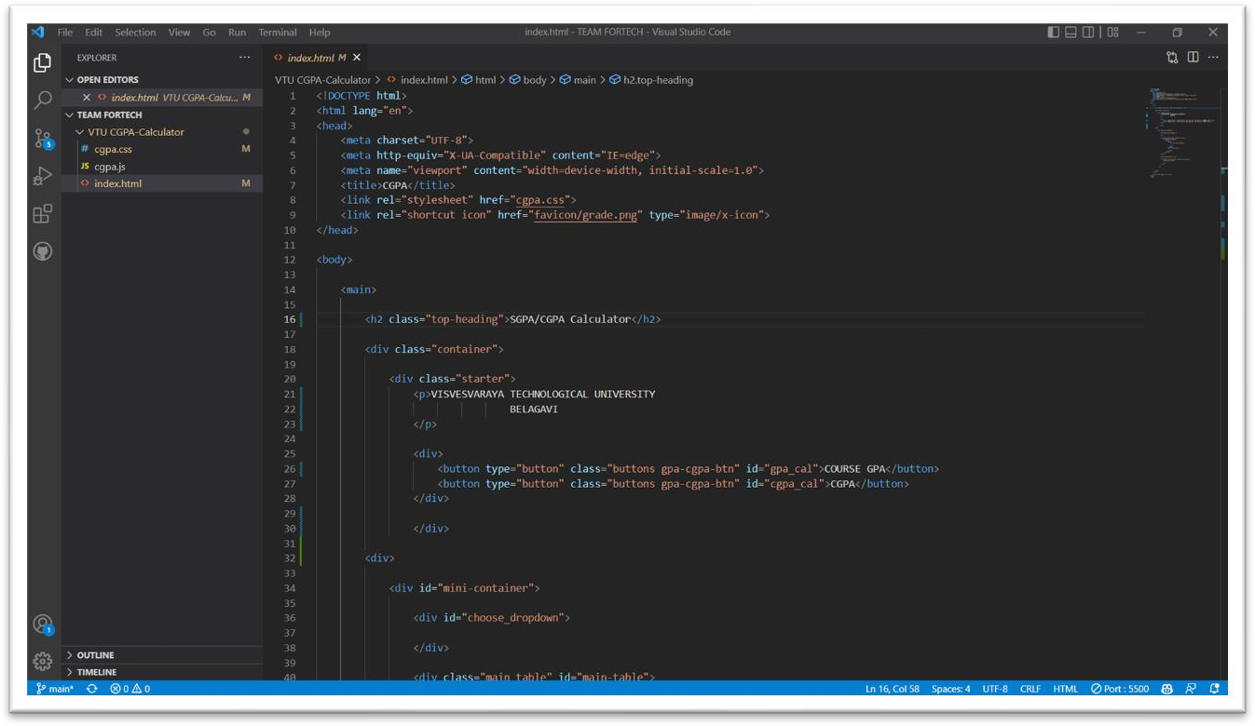Source code is further executed with the help of **Live Server Extension**

1. This page takes us to the **Home page** of the website from where we can access various pages like about, courses, trainers, events, pricing, contact. The login and signup can also be done from this page of the website.

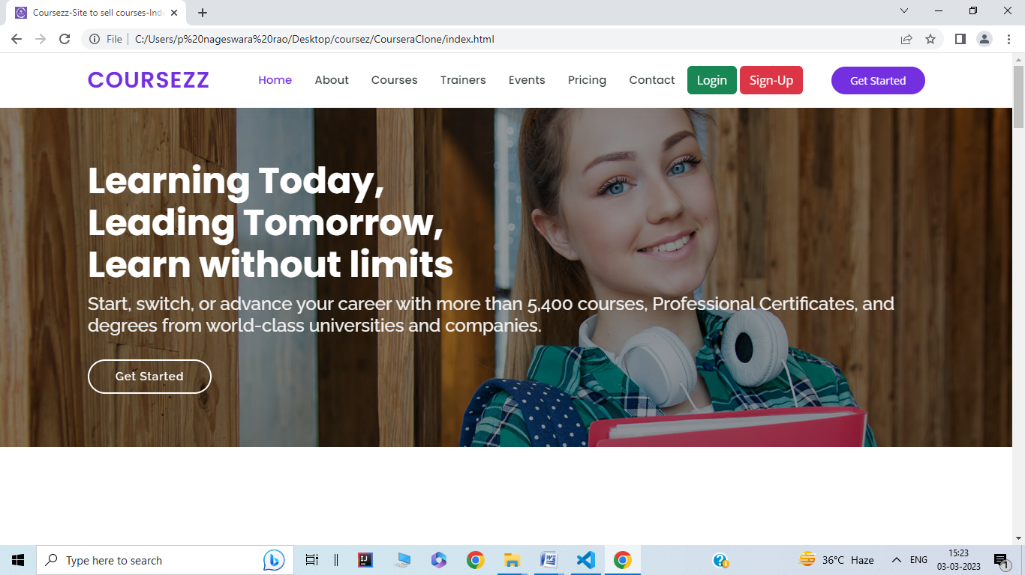

1. This is the **Signup page** in which the new user can login to this website to make use of the courses available in this website. The **login page** is also available which the existing users can make use of. The details of the users is stored in the database at the backend using php.

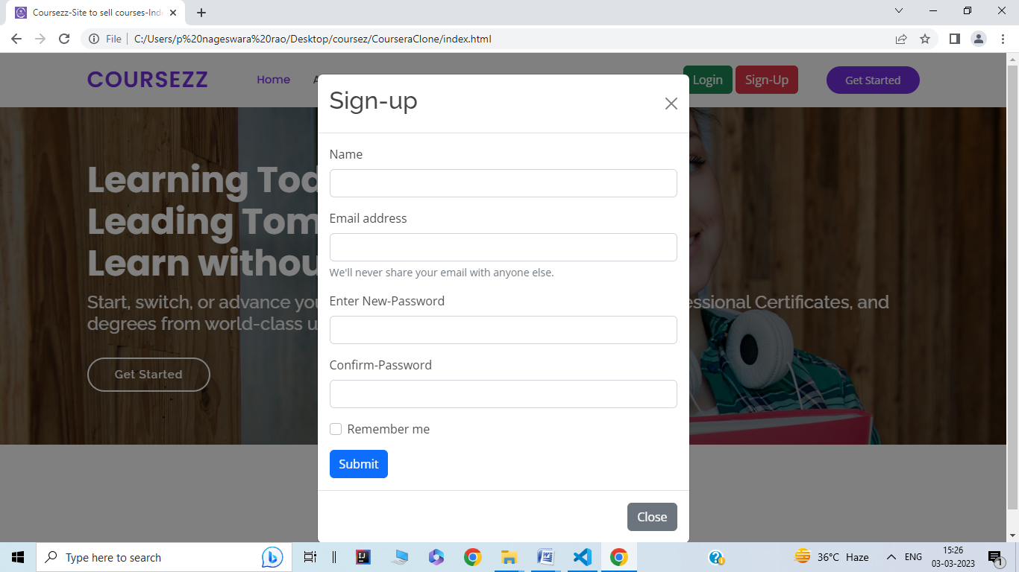

1. This page shows the **course details** in which the user can see the details of each and every course like the name of the trainer, course fee, schedule and available slots. The user can buy the course also.

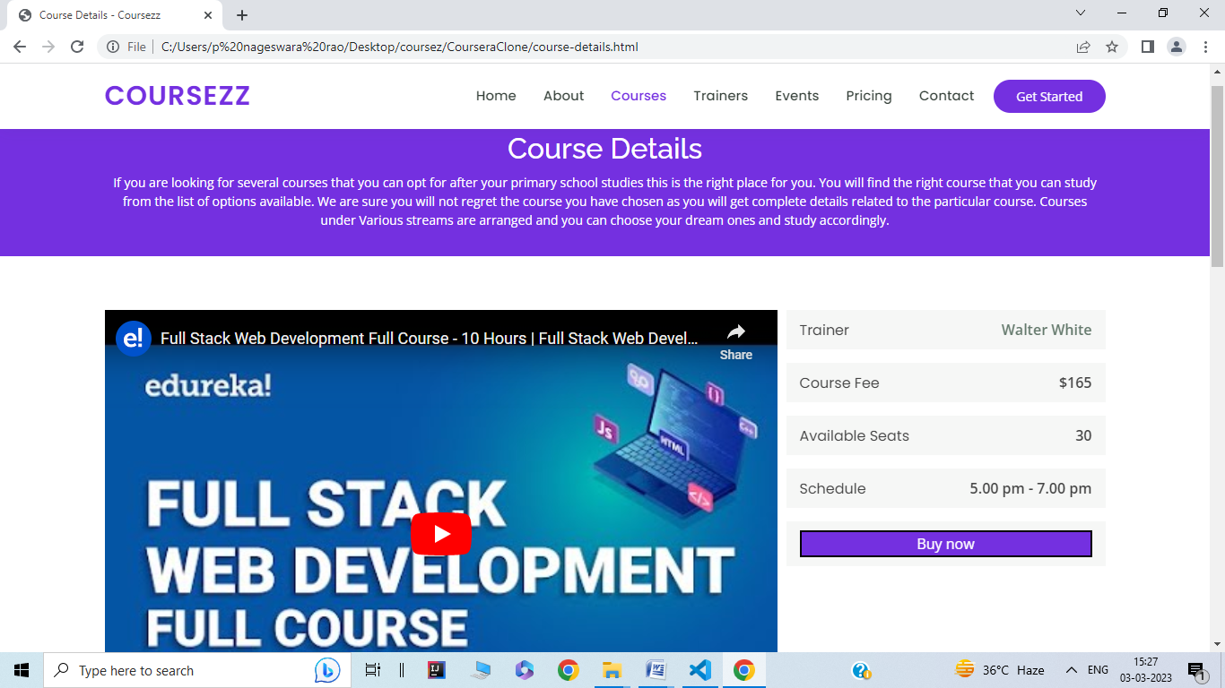

1. This page is the **payment section** of the website in which the user can pay for the courses which he/she would like to buy. The card details are asked from the user to proceed with the online payment and these details are stored at the backend .

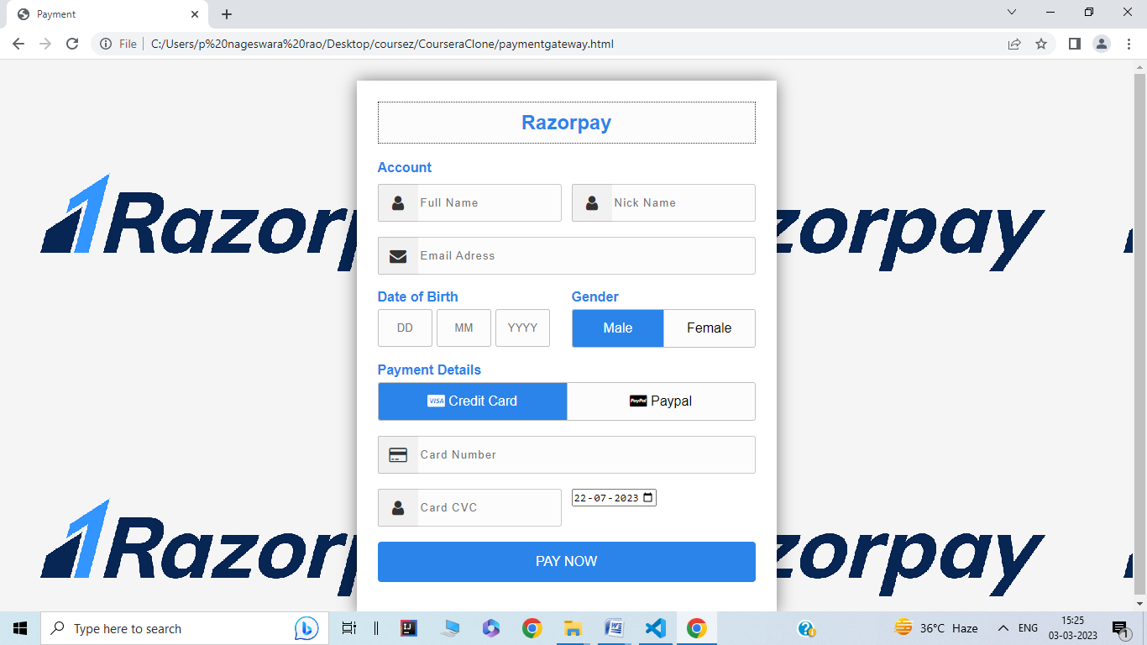

1. This is the **contact us page** for the users to send inquiries or requests for more information. This includesthe details of the user like their name, email and the query that they wanted to ask.

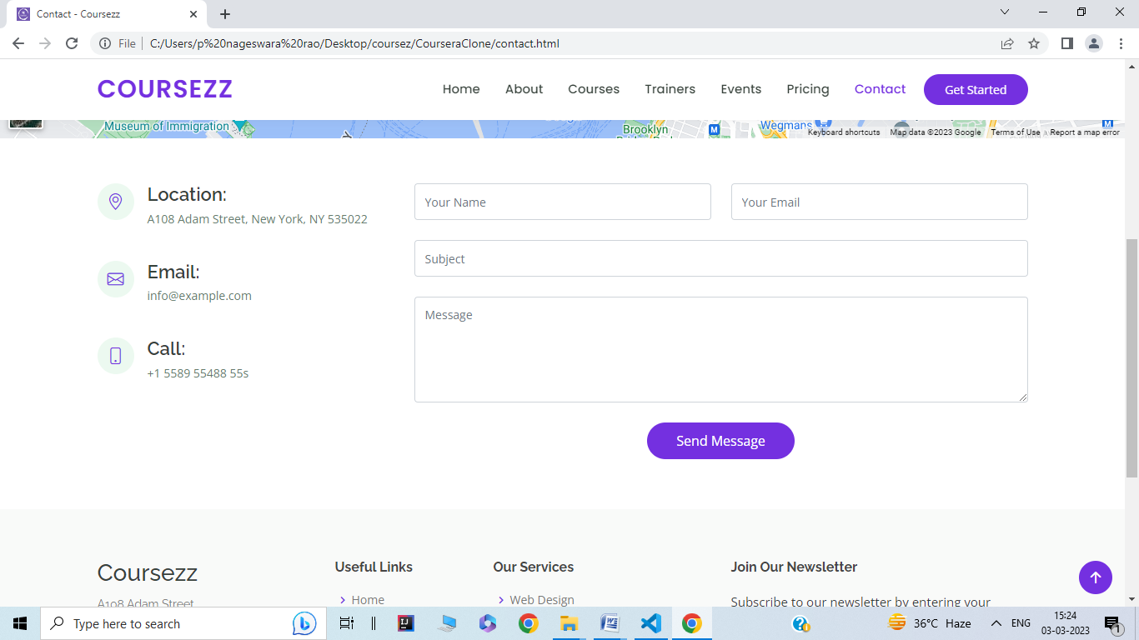

# CONCLUSION

The package was designed in such a way that future modifications can be done easily. The following conclusions can be deduced from the development of the project:

* Automation of the entire system improves the efficiency
* It provides a friendly graphical user interface which proves to be better when compared to the existing system.
* It gives appropriate access to the authorized users depending on their permissions.
* It effectively overcomes the delay in communications.
* Updating of information becomes so easier
* System security, data security and reliability are the striking features.
* The System has adequate scope for modification in future if it is necessary.

# REFERENCE

##### BOOKS:

* + ASP.NET Core 5 and React **-** Carl Rippon
  + Hands-on JavaScript for Python Developers - Sonyl Nagle
  + Full-Stack React, TypeScript, and Node – David Chai
  + Full Stack Development with J Hipster - Deepu K Sasidharan, Sendil Kumar.

##### WEBSITES:

* + <https://www.upgrad.com/full-stack-dev/training>
  + https:/[/www.digitala](http://www.digitalacademy360.com/fullstack/development)c[ademy360.com/fullstack/development](http://www.digitalacademy360.com/fullstack/development)
  + https:/[/www.im](http://www.imarticus.org/)a[rticus.org/](http://www.imarticus.org/)